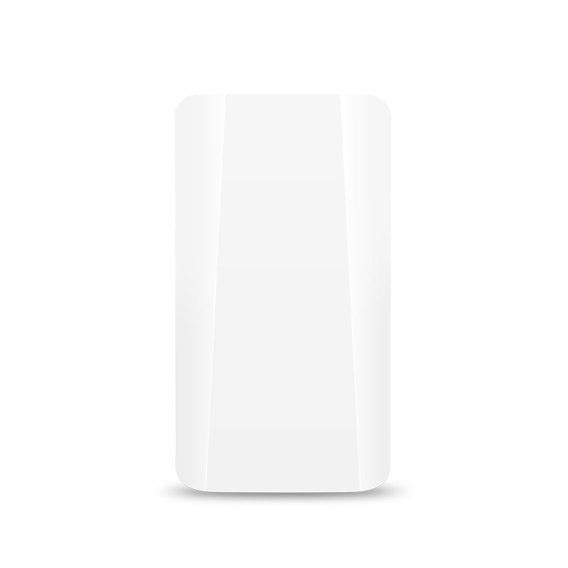300M Elevator Digital Bridge

B401 is a high-performance enterprise-level outdoor bridge product that works in the 2.4G frequency band and supports 802.11N technology. Unique digital tube pairing technology, without computer configuration, easily complete the pairing of point-to-point and point-to-multipoint (within 8 o'clock) devices. 100M network interface, 2.4G 802.11N MIMO technology, wireless processing speed up to 300Mbps. The power supply mode is flexible, supporting 24V POE network cable power supply and 12V 1A DC local power supply, and the network cable power supply distance can reach 50-70 meters (depending on the network cable material). It adopts outdoor IP65 windproof, rainproof, dustproof and sun protection grade shell design, which can easily adapt to various harsh outdoor environments. Built-in 12dBi dual-excited plate antenna, easy and quick installation. It has the characteristics of high performance, high gain, high receiving sensitivity, high bandwidth, etc., which greatly enhances the wireless transmission performance and stability, and is mainly suitable for elevator monitoring and other places.

**Hardware product features**

**22222Super cost-effective hardware configuration**

Enterprise-level master chip, industrial-level circuit design, support IEEE802.11A/N protocol, can provide 300Mbps wireless access speed and 100Mbps Ethernet switching processing speed. The excellent anti-high and low temperature design fully guarantees the real-time, long-term, stable and high-efficiency transmission of user network data in extreme environments, and improves user experience.

**22222Powerful wireless transmission capability**

The circuit design with high power and high receiving sensitivity greatly enhances the wireless transmission distance and improves the performance and stability of wireless transmission.

**22222Simple and efficient pairing**

No need for network expertise, no need for computer operation, easily dial the code and adjust the master and slave device digital tubes to the same value to complete the point-to-point, point-to-multipoint (within 8 points) pairing work.

**22222Flexible power supply**

The equipment not only supports the power supply mode of POE remote network cable power supply, but also supports the power supply mode of 12V 1A DC local connection power supply, which can meet the needs of various scenarios, reduce construction costs, and flexibly select power supply methods.

**22222Stylish and compact, easy to install**

The appearance is stylish and compact, and the installation method is flexible and simple. It has a wall-mounted and pole-mounted fixed installation method. On the basis of not affecting the original design, it greatly reduces the difficulty of construction for construction personnel and improves construction efficiency.

**Software features**

**22222Humanized unified management & settings**

Wired or wireless connected devices can access 169.254.254.254 through the WEB browser, and all devices on the local area network can be displayed in a list, and the devices can be easily configured and wirelessly optimized. Solve the problem that the LAN wireless bridge is difficult to manage and greatly simplify the work of the network administrator.

**22222A clear overview of the equipment**

Log in to the device through a WEB browser to view the connection system status, bridge status, and interface status information in real time. The simple and clear interface allows users to know the working status of the device in real time.

**Fool-style quick setup & powerful wireless optimization22222**

Users do not need to understand too much wireless knowledge, do not need too much professional knowledge, and can realize the pairing of point-to-point and point-to-multipoint (within 8 points) devices in a few simple steps. Simple settings can complete wireless optimization, and easily improve link transmission quality and use effect.

**22222Protect users' network security at all times**

The equipment bridge and VAP signal adopt advanced WPA-PSK&WPA2-PSK encryption strategy, and the bridge signal cannot be searched by wireless terminals. The VAP signal supports SSID hiding, which protects the user's network from hacker attacks at all times and ensures the user's data security.

**22222Easily adapt to multiple network environments**

The device supports gateway mode and bridge transparent transmission mode. The gateway mode supports automatic acquisition, PPPoE, and static IP, which can easily adapt to various network environment requirements.

**22222Cloud management**

Unique cloud management, as long as the network where the device is connected to the Internet, easy configuration can access the configuration device anywhere.

**22222Simple and efficient system configuration function**

Network time synchronization, access password modification, local backup/restore settings, factory reset, local/online upgrade, immediate/timed restart, simple and clear functions allow you to easily complete the system settings of the device and improve the robustness of the device.

Product technical specifications

|  |  |
| --- | --- |
| Product parameter | |
| **Hardware Configuration** |  |
| Model | B401 |
| Main chip | High-performance enterprise chip |
| Main frequency | 580MHz |
| Wireless technology | 2.4G:300M 802.11b/g/n MIMO Technology |
| Memory | 8MB DDR RAM |
| Flash | 2MB |
| Network Interface | 1*10/100 Mbps adaptive network interface |
| Button | 1*Digital switch/reset button,  short press the digital tube to display the value plus one,  long press for 15 seconds to restore factory settings |
| Indicator light | LAN network interface status indicator, power indicator |
| Power supply | 24V 0.5A non-standard POE power supply;  DC 12V 1A, power consumption <10W |
| Working environment | Temperature: -30℃～+55℃(work), -40℃～+70℃(storage)  Humidity (non-condensing): 10% to 90% (working), 5% to 95% (storage) |
| Product Size | N/A |
| Product weight | Gross weight: 0.60Kg Net weight: 0.35Kg |
| Sky line | Built-in dual-polarization high-gain 12dBi directional plate antenna (horizontal wave half-angle 45°, vertical wave half-angle 45°) |

|  |
| --- |
|  |

|  |  |
| --- | --- |
| **RF characteristics** |  |
| Frequency Range | ISM band: 2.300GHz ~ 2.4835GHz |
| Channel distribution | 2.4G：1、2、3、4、5、6、7、8、9、10、11、12、13、  32、33、37、38、42、43 |
| Modulation | OFDM = BPSK,QPSK,16-QAM,64-QAM;DSSS = DBPSK,DQPSK,CCK |
| Output Power | 802.11n: @MCS7:14±2DB, @MCS0:16±2DB  802.11g: @54M:15±2DB, @6M:17±2DB  802.11b: @11M:17±2DB, @1M:19±2DB |
| Receiving sensitivity | 802.11n: -70dbm@MCS7, -88dbm@MCS0  802.11g: -72dbm@54Mbps, -88dbm@6Mbps  802.11b: -85dbm@11Mbps, -94dbm@1Mbps |
| EVM | 802.11n: ≤-28 DB 802.11g: ≤-25 DB 802.11b: ≤-10 DB |
| Frequency deviation | ±20ppm |

|  |  |
| --- | --- |
| **Software features** |  |
| Operating mode | Master AP, slave AP (dial code conversion) |
| Networking method | Point-to-point, point-to-multipoint (within 8 points) |
| Management method | Chinese WEB remote management |
| Internet | Static IP/dynamic acquisition |
| Bridge management | LAN bridge list real-time remote management equipment |
| Wireless management | WLAN configuration/WLAN analyzer/Radio configuration/wireless users |
| System | Device description, time zone and time configuration, login password modification, backup/restore system settings |
| System update | Local update and online update based on WEB browser |
| Restart | Restart immediately / scheduled |