8 Port Gigabit AI PoE Switch

【Introduction】

8 Port Gigabit Intelligent Ethernet PoE Switch, using high-quality high-speed network IC and the most stable PoE chip, the switch incorporates the latest AI functions, equipped with two types port priorities, PoE priority and Network priority, one-key smart. The PoE port meets the 802.3af or 802.3at standard. At the same time, port 1/2 supports HiPoE and the power can reach 60W; The power consumption indicators can help to understand the overall power consumption of the product easily. This series of PoE switches can provide seamless connection for 10/100M Ethernet, and the PoE power supply port can automatically detect and supply power to powered devices that comply with IEEE802.3af or IEEE802.3at standards, and non-PoE devices intelligently detect no power supply, only data is transferred.

【Main Features】
- 8*10/100/1000M rate auto adaptive PoE ports
- Working with IEEE 802.3af/at compliant PDs, expands home and office network
- Flow control mode: full-duplex adopts IEEE 802.3x standard, half-duplex adopts Back pressure standard
- Support Port Auto-flip (Auto MDI/MDIX）
- One-key smart switch, supports VLAN, Default, Extend three working modes
- Support PoE Watchdog Function,Support link monitoring, abnormal self-test and recovery
- Port 1/2 supports HiPoE and the power can reach 60W
- Support sequence port PoE priority, the higher the port priority
- Support port Surge Protection: Common mode 4KV, Differential mode 2KV; ESD:air 8KV，Contact 6KV

【Application Environment】
- Metro Optical Broadband Network: Data network operators such as telecommunications, cable TV, and network system integration,etc.
- Broadband private network: Suitable for financial, government, oil, railway, electric power, public security, transportation, education and other industries
- Multimedia transmission: Integrated transmission of images, voice and data, suitable for remote teaching, conference TV, videophone and other applications
- Real-time monitoring: Simultaneous transmission of real-time control signals, images and data

【Specifications】
I/O Interface
Power | Input: AC 100-240V, 50/60Hz
Ethernet | 8 *10/100/1000M PoE Port
Performance
Switching Capacity | 16Gbps
Throughput | 11.9Mpps
Packet Buffer | 1Mb
MAC Address | 2K
Jumbo Frame | 9216bytes
Transfer Mode | Store and forward
MTBF | 100000 hour
Standard
Network protocol | IEEE802.3 (10Base-T)  IEEE802.3u (100Base-TX)  IEEE802.3ab (1000Base-TX)  IEEE802.3x (Flow control)
PoE Protocol | IEEE802.3af （15.4W）  IEEE802.3at （30W）  IEEE802.3bt （60W）
Industry Standard | EMI: FCC Part 15 CISPR (EN55032) class A  EMS: EN61000-4-2 (ESD)、  EN61000-4-4 (EFT)、  EN61000-4-5 (Surge)
Network Medium | 10Base-T : Cat3、4、5 or above UTP(≤100m)  100Base-TX : Cat5 or above UTP(≤100m)  1000Base-TX : Cat5 or aboveUTP(≤100m)
Protection
Security Certificate | CE、FCC、RoHS
Environment
Working Environment | Working Temperature：-20~50°C  Storage Temperature：-40~85°C  Working Humidity ：10%~90%，non-condensing  Storage Temperature：5%~90%，non-condensing  Working Height：Maximum10,000 feet  Storage heigh：Maximum 10,000 feet
Indication
LED Indicators | PWR（power supply），Mode（DIP），1-8 Green（Link&Data）
PWR | Lighting：Powered  Un-Light：No Power
Mode | Lighting：VLAN  Un-Light：Default  Flashing：Extend
1-8 Green | Lighting：Connecting  Flashing：Data Transmit  Un-Light：Disconnect
DIP Switch | VLAN, Default, Extend
VLAN | Port Isolation, 1-6 port is isolated each other, but all can communicate with uplink port 7/8, AI enable
Default | Normal mode, all port can communicate with each other, The port AI mode is closed.
Extend | Extend Mode, 3-6 port support 250 meters transmission on 10Mbps/s ,AI enable
Mechanical
Structure Size | Product Dimension (L*W*H): 200mm*118mm*44mm  Package Dimension (L*W*H): 245mm*190mm*60mm  N.W：0.6kg  G.W：0.9kg
Packing Info | Carton MEAS：505*320*400mm  Packing Qty：20 units  Packing Weight：19KG
Power Voltage | Input Voltage ：AC 100-240 V  Power supply：52V2.3A
Package List | Switch 1 pcs, Power cord 1 pcs, User manual 1 pc, Certification 1 pc
Ordering Info
HR900-AXG-80N | 8-port 10/100/1000M AI PoE Switch

【Product Picture】
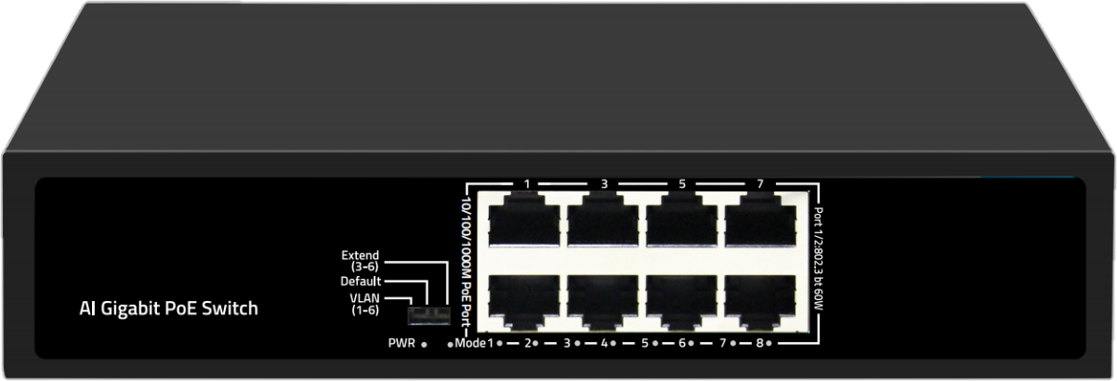

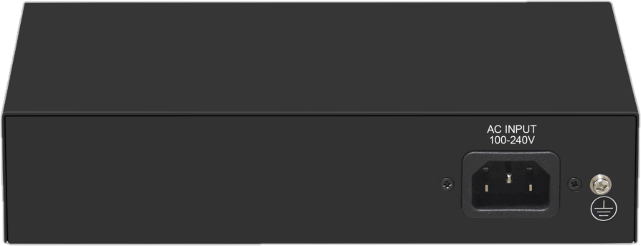

【Application】

