27 Port Gigabit Uplink 24 Port 100M PoE Switch

【Introduction】

27 Port Gigabit Uplink 24 Port 100M PoE Switch, using high-quality high-speed network IC and the most stable PoE chip, PoE Port support 802.3af and 802.3at standard both, this series of PoE Switch can be 10/100M Ethernet The network provides a seamless connection, and the PoE power port can automatically detect and power the powered devices that comply with the IEEE802.3af or IEEE802.3at standards. The non-PoE device intelligently detects no power and only transmits data.

PoE is Power over Ethernet, which refers to the transmission of data signals to some IP-based terminals (such as IP phones, wireless access APs, network cameras, etc.), but also provides DC power for this device. Technology, these devices that receive DC power are called powered devices.

【Main Features】

24*10/100M POE ports + 2* 10/100/1000M Ethernet Uplink ports+1* Gigabit SFP Uplink Port；

Comply with IEEE 802.3, IEEE 802.3u, IEEE802.3ab ,IEEE802.3z IEEE802.3x standards；

Ethernet port supports 10/100M adaptive；

Flow control mode: full-duplex adopts IEEE 802.3x standard, half-duplex adopts Back pressure standard；

Support port auto flip (Auto MDI/MDIX)；

Automatically supplied to adaptive devices；

Panel indicator monitoring status and help failure analysis；

Support for VLAN mode, OFF mode and Extend mode；

Compatible with 1 U rack installation

【Application Environment】
- Metro Optical Broadband Network: Data network operators such as telecommunications, cable TV, and network system integration,etc.
- Broadband private network: Suitable for financial, government, oil, railway, electric power, public security, transportation, education and other industries
- Multimedia transmission: Integrated transmission of images, voice and data, suitable for remote teaching, conference TV, videophone and other applications
- Real-time monitoring: Simultaneous transmission of real-time control signals, images and data

【Specifications】
I/O Interface
Power | Input: AC 100-240V, 50/60Hz
Ethernet | 24 *10/100M PoE Port  2* 10/100/1000M Ethernet Uplink ports  1* Gigabit SFP Uplink Port
Performance
Switching Capacity | 10.8Gbps
Throughput | 8.035Mpps
Packet Buffer | 1.5Mb
MAC Address | 2K
Jumbo Frame | 9216bytes
Transfer Mode | Store and forward
MTBF | 100000 hour
Standard
Network protocol | IEEE802.3 (10Base-T)  IEEE802.3u (100Base-TX)  IEEE802.3ab(1000Base-TX)  IEEE802.3z(1000Base-FX)  IEEE802.3x (Flow control)
PoE Protocol | IEEE802.3af （15.4W）  IEEE802.3at （30W）
Industry Standard | EMI: FCC Part 15 CISPR (EN55032) class A  EMS: EN61000-4-2 (ESD)、  EN61000-4-4 (EFT)、  EN61000-4-5 (Surge)
Network Medium | 10Base-T : Cat3、4、5 or above UTP(≤100m)  100Base-TX : Cat5 or above UTP(≤100m)  1000Base-TX : Cat5 or above UTP(≤100m)
Optical Media | Multimode fiber : 50/125, 62.5/125, 100/140μm  Single mode fiber: 8/125, 8.7/125, 9/125, 10/125μm
Protection
Security Certificate | CE、FCC、RoHS
Environment
Working Environment | Working Temperature：-20~50°C  Storage Temperature：-40~85°C  Working Humidity ：10%~90%，non-condensing  Storage Temperature：5%~90%，non-condensing  Working Height：Maximum10,000 feet  Storage heigh：Maximum 10,000 feet
Indication
LED Indicators | PWR（power supply）,SW（DIP）,1-27 Green（Link&Data）
PWR | Lighting：Powered  Un-Light：No Power
SW | Lighting：VLAN  Un-Light：OFF  Flashing：Extend
1-27 Green | Lighting：Connecting  Flashing：Data Transmit  Un-Light：Disconnect
DIP Switch | VLAN ,OFF ,Extend
VLAN | Port isolation mode. In this mode, the PoE ports (1-24) of the switch cannot communicate with each other, and can only communicate with the UP-link port.
OFF | Normal mode, all port can communicate with each other, the transmission distance is within 100 meters, the transmission rate is 10M / 100M adaptive
Extend | Link extension mode, 9-24 ports PoE power supply and data transmission distance can be extended to 250 meters, the transmission rate becomes 10M
Mechanical
Structure Size | Product Dimension (L*W*H): 320*207*45mm  Package Dimension (L*W*H): 370*290*85mm  N.W：1.9kg  G.W：2.4kg
Packing Info | Carton MEAS：445*310*390mm  Packing Qty：5 units  Packing Weight：13KG
Power Voltage | Input Voltage ：AC 100-240 V  Power supply：52V5.76A
Package List | Switch 1 pcs, Power cord 1 pcs, User manual 1 pcs, Certification 1 pcs, Brackets 1 pair
Ordering Info
ZX901-AF-2421GS-300 | 27 Port Gigabit Uplink 24 Port 100M PoE Switch(300w)

【Product Picture】
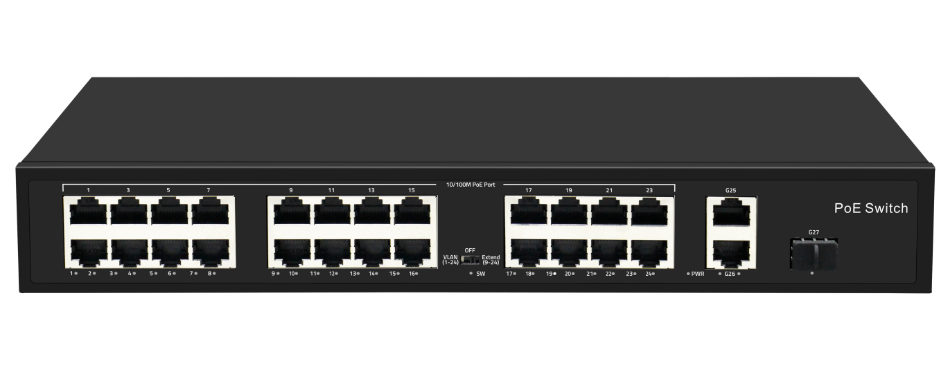

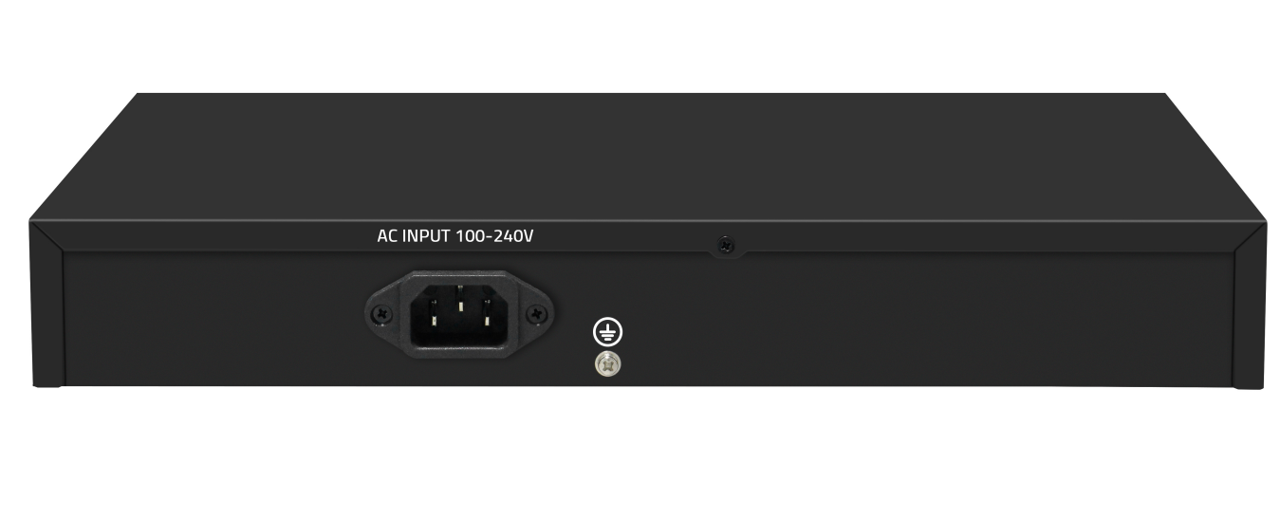

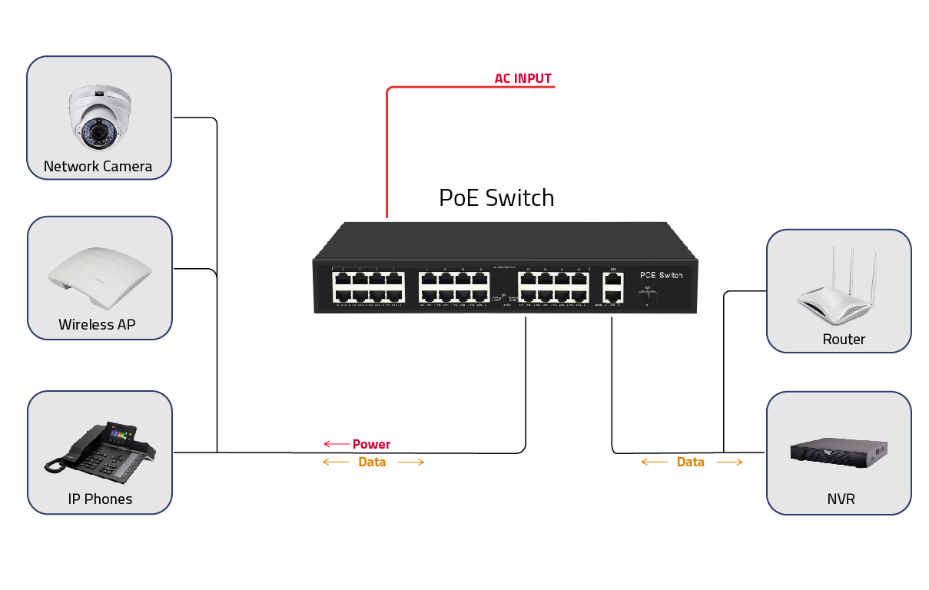
【Application】

