6-Port Gigabit PoE Switch
【Introduction】
6-Port Gigabit PoE switch, using high-quality high-speed network IC and the most stable PoE chip, The PoE port meets the 802.3af or 802.3at standard. This series of PoE switches can provide seamless connection for 10/100/1000M Ethernet, and the PoE power supply port can automatically detect and supply power to powered devices that comply with IEEE802.3af or IEEE802.3at standards, and non-PoE devices intelligently detect no power supply, only data is transferred.

【Main Features】
- 4*10/100/1000M POE Ports + 1*1000M RJ45 Port+1*1000M SFP Port
- Comply with IEEE 802.3, IEEE 802.3u,IEEE802.3ab,IEEE802.3z standards
- port 1 support BT 40W;
- Ethernet port 10/100/1000M rate auto adaptive
- Flow control mode: full-duplex adopts IEEE 802.3x standard, half-duplex adopts Back pressure standard
- Support Port Auto-flip (Auto MDI/MDIX）
- Panel indicators to monitor working status and help fault analysis
- One-key smart switch, supports VLAN,Default,Extend

【Application Environment】
- Metro Optical Broadband Network: Data network operators such as telecommunications, cable TV, and network system integration,etc.
- Broadband private network: Suitable for financial, government, oil, railway, electric power, public security, transportation, education and other industries
- Multimedia transmission: Integrated transmission of images, voice and data, suitable for remote teaching, conference TV, videophone and other applications
- Real-time monitoring: Simultaneous transmission of real-time control signals, images and data

【Specifications】
I/O Interface
Power | Input: AC 100-240V, 50/60Hz
Ethernet | 4*10/100/1000M PoE Port  1*1000M RJ45 Port  1* Gigabit SFP Uplink Port
Performance
Switching Capacity | 12Gbps
Throughput | 8.928Mpps
Packet Buffer | 1Mb
MAC Address | 2K
Jumbo Frame | 9216bytes
Transfer Mode | Store and forward
MTBF | 100000 hour
Standard
Network protocol | IEEE802.3 (10Base-T)  IEEE802.3u (100Base-TX)  IEEE802.3ab(1000Base-TX)  IEEE802.3z(1000Base-FX)  IEEE802.3x (Flow control)
PoE Protocol | IEEE802.3af （15.4W）  IEEE802.3at （30W）
Industry Standard | EMI: FCC Part 15 CISPR (EN55032) class A  EMS: EN61000-4-2 (ESD),  EN61000-4-5 (Surge)
Network Medium | 10Base-T : Cat3、4、5 or above UTP(≤100m)  100Base-TX : Cat5 or above UTP(≤100m)  1000Base-TX : Cat5 or above UTP(≤100m)
Optical Media | Multimode fiber : 50/125, 62.5/125, 100/140μm  Single mode fiber: 8/125, 8.7/125, 9/125, 10/125μm
Protection
Security Certificate | CE、FCC、RoHS
Environment
Working Environment | Working Temperature：-10~50°C  Storage Temperature：-40~70°C  Working Humidity ：10%~90%，non-condensing  Storage Temperature：5%~90%，non-condensing
Indication
PWR（power supply） | Lighting：Powered  Un-Light：No Power
Mode（DIP） | Lighting：VLAN  Un-Light：Default  Flashing：Extend
1-6 Gree（Link&Data） | Lighting：Connecting  Flashing：Data Transmit  Un-Light：Disconnect
DIP Switch | VLAN：Port isolation mode. In this mode, the PoE ports (1-4) of the switch cannot communicate with each other, and can only communicate with the UP-link port.  Default : Normal mode, all port can communicate with each other, the transmission distance is within 100 meters  Extend：Link extension mode, 3-4 ports PoE power supply and data transmission distance can be extended to 250 meters, the transmission rate becomes 10M
Mechanical
Structure Size | Product Dimension : 200*118*44.5mm  Package Dimension : 245*190*60mm  N.W：0.63kg  G.W：0.93kg
Packing Info | Carton MEAS：520*320*400mm  Packing Qty：20units  Packing Weight：19.6KG
Power Voltage | Input Voltage ：AC 100-240 V  Power supply：52V1.25A
Package List | Switch 1 pcs, Power cord 1 pcs, User manual 1 pc, Certification 1 pc,
Ordering Info
ZX901-AXG-411NS | 6 Port Gigabit PoE Switch ,52V1.25A

【产品效果】
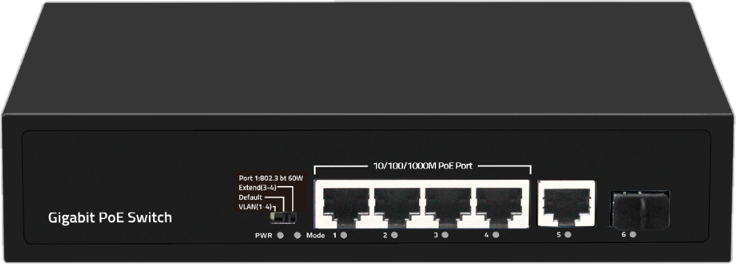

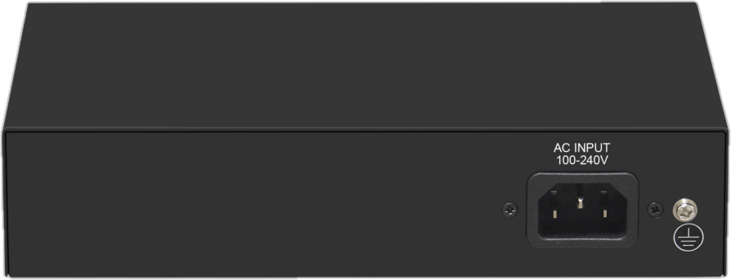

【应用拓扑】

