High-speed & High-efficiency

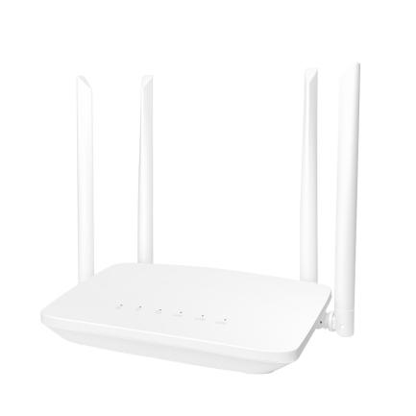

# CPE320K

4G Wireless Router

# Overview

CPE300K is a new 4G LTE CPE with LTE CAT 4 technology. The router is mainly aimed at the office, home, security and IoT. It provides high- speed and reliable routing and data transmission capabilities，to meet their different application scenarios.

# Highlight

* MTK7628KN CPU,
* Memory：8MB ,
* 4G Module：LTE CAT4,
* Flash：2MB ,
* 1*10/100Mbps RJ45 WAN 2*10/100Mbps RJ45 LAN
* 1*Sim Standard Card Slot
* Throughput：LTE CAT4

FDD-LTE 150Mbps/50Mbps

* Support Multiple Internet Connect：4G，PPPOE，APN
* Radio rate up to 300Mbps，support wireless security functions
* Support 3*10/100Mbps RJ45,
* Support SIM lock card and traffic
* Support multi-carrier (4G LTE),
* External reset button,
* Power supply：DC 12V 1A(EU Adapter)
* Support external LED indicator,
* Button：Power, Reset，WPS , WiFi,

statistics

* Support IPV4， Protocol
* Support antenna：2*WIFI+2*LTE,(5dBi gain.)

# Benefit

**Data Sheet**

## Wireless WAN Connectivity

The 4G router enables easy-to-install wireless connectivity in small business

or remote office locations. Ideal for small businesses ,home ,offices and mobile networks; the 4G router provides wired Ethernet, and 4G wireless WAN connectivity to keep you and your business up and running.

## Secure and Reliable

a-LAN connections are protected with advanced WiFi encryption.

b-Main office access and business transactions are protected by APN capability, and other security features to ensure your network stays secure.

c-Designed for small office/home /IoT/Security deployments.

## Product Architecture Diagram

**LTE CAT4**

**CPE320K**

**4G Router**

**MTK7628KN**

**Memory**

8MB

Flash

**2MB**

**Power**

**12V 1A**

**1RJ45* WAN**

**3*RJ45 Ports**

**LAN/WAN**

**2RJ45* LAN**

# Hardware Speciﬁcation

Application Scenarios Concurrent Clients CPU

**Data Sheet**

Interface Button

Power Suppply

Flash/Memory SIM Card

LED

Dimensions Antennas Antenna Gain Frequency

Radio Rate

IPV4

Wireless Security

Home，Office，IoT，Security 30

MTK7628KN

1 * WAN Port+2* LAN Ports

Reset，WPS，

DC12V /1A

2MB/8MB

Standard SIM

PWR，WAN，LAN，2.4Gwifi，4G

222*80*21(mm）

2.4G:2T2R 4G :2T2R

5dBi

802.11b/g/n：2.4~2.4835GHz

2.4G: Up to 300Mbps

Support

WPA-PSK/WPA2-PSK、WPA/WPA2

# Hardware Speciﬁcation

Modulation

Receiver Sensitivity

11b：DSS:CCK@5.5/11Mbps,DQPSK@2Mbps,

DBPSK@1Mbps

11g：OFDM:64QAM@48/54Mbps,16QAM@24Mbps,

QPSK@12/18Mbps,BPSK@6/9Mbps

11n：MIMO-OFDM:BPSK,QPSK,16QAM,64QAM

11b: <-84dbm@11Mbps；

11g: <-69dbm@ 54Mbps；

11n: HT20<-67dbm HT40: <-64dbm

4G Module

LTE CAT4

Frequency

4G LTE FDD：B1/B3/B5/B8 4G LTE TDD:B34/B38/B39/B40/B41

# Product Specification

**Data Sheet**

|  |  |
| --- | --- |
| Mode | 4G Router |
| WiFi Setting | Wireless Setting、Channel bandwidth Setting |
| Status | CPU Status、Interface Status、4G Status Client List  Internet Status |
| Network | LAN WAN DHCP APN |
| Traffic assistant | Statistics and display the usage of traffic in 4G mode. |
| Sys | Username Managerment Reboot Upgrade/Restore/Bankup Sys time & date  Sys logs |
| Setting Guide | Type of connect Internet Network  WiFi |
| Operating Environment | Operating Temperature：Normal:0°C to +45°C; Operating Humidity：-20° C to +70° C Operating Humidity：5%~ 95%  Storage Humidity：5%~ 95% |

