High-speed & High-efficiency

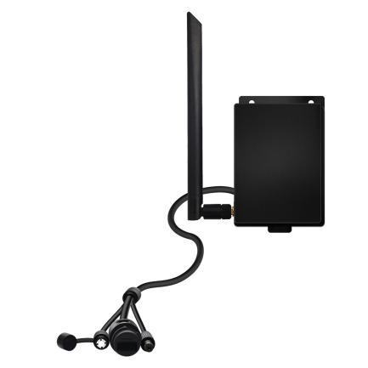

# QC301K

Outdoor 4G Wireless Router

# Overview

QC301K is a new 4G LTE CPE with CAT 4 technology. The router is mainly aimed at home, security，IoT and for IP camera. It provides high-speed and reliable routing and data transmission capabilities，to meet their different application scenarios.

# Highlight

* MTK7628KN CPU
* Memory：8MB
* 4G Module：LTE CAT4
* Flash：2MB
* 1*10/100Mbps RJ45 LAN
* 1*SIM Card Slot
* Power Output Port（12v 1a）
* Throughput：LTE CAT4

FDD-LTE 150Mbps/50Mbps

* Support Multiple Internet Connect： 3G，4G，APN
* Radio rate up to 300Mbps，support wireless security functions
* Support 1*10/100Mbps RJ45
* Support SIM lock card and traffic
* Support multi-carrier (2G/3G/4G LTE)
* External reset button
* Power supply：DC 12V 1-1.5A
* Support external LED indicator
* Button：Reset

statistics

* Support TR069 and upgrade online
* Support IPV4， Protocol
* Support antenna：1*4g antenna(5dBi gain)+3dBi internal wifi antenna

# Benefit

**Data Sheet**

## Wireless Lan Connectivity

The 4G router enables easy-to-install wireless connectivity in small business

or remote office locations. Ideal for small businesses,home ,offices and mobile networks; the 4G router provides wired Ethernet, and 3G/4G wireless Lan connectivity to keep you and your business up and running.

## Secure and Reliable

a-LAN connections are protected with advanced WiFi encryption.

b-Main office access and business transactions are protected by VPN capability, and other security features to ensure your network stays secure.

c-Designed for small office/home /IoT/Security deployments.

## Product Architecture Diagram

**LTE CAT4**

**QC301K 4G Router**

**MTK7628KN**

**/**

**Memory**

8MB

Flash

**2MB**

**Power**

**12V 1-1.5A**

/////////

**1*FE Ports**

**LAN**

**1FE* LAN**

# Hardware Speciﬁcation

Application Scenarios Concurrent Clients CPU

**Data Sheet**

Interface Button

Power in

Flash/Memory SIM Card

LED

Dimensions Antennas Antenna Gain Frequency

Radio Rate

IPV4

Wireless Security

Home，Office，IoT，Security 30

MTK7628KN

1*100Mbps LAN

Reset

DC12V /1-1.5A

2MB/8MB

Nano SIM

PWR，LAN，2.4Gwifi，4G

135*98*30(mm）

2.4G:1T1R 4G :1T1R

5dBi

802.11b/g/n：2.4~2.4835GHz

2.4G: Up to 300Mbps

Support

WPA-PSK/WPA2-PSK、WPA/WPA2

# Hardware Speciﬁcation

Modulation

Receiver Sensitivity

11b：DSS:CCK@5.5/11Mbps,DQPSK@2Mbps,

DBPSK@1Mbps

11g：OFDM:64QAM@48/54Mbps,16QAM@24Mbps,

QPSK@12/18Mbps,BPSK@6/9Mbps

11n：MIMO-OFDM:BPSK,QPSK,16QAM,64QAM

11b: <-84dbm@11Mbps；

11g: <-69dbm@ 54Mbps；

11n: HT20<-67dbm HT40: <-64dbm

4G Module

LTE CAT4

Frequency

GSM GNSS

4G LTE FDD：B1/B3/B7/B8/B20/B28 4G LTE TDD: B39/B40/B41

3G: B1/B8

900MHz/1800MHz

GPS, GLONASS, BeiDou/Compass, Galileo, QZSS

# Product Specification

**Data Sheet**

|  |  |
| --- | --- |
| Mode | 4G Router |
| WiFi Setting | Wireless Setting、Channel bandwidth Setting |
| Status | CPU Status、Interface Status、4G Status Client List  Internet Status |
| Network | LAN WAN DHCP APN |
| Traffic assistant | Statistics and display the usage of traffic in 4G mode. |
| Sys | Username Managerment Reboot Upgrade/Restore/Bankup Sys time & date  Sys logs |
| Setting Guide | Type of connect Internet Network  WiFi |
| Operating Environment | Operating Temperature：Normal:0°C to +45°C; Operating Humidity：-20° C to +70° C Operating Humidity：5%~ 95%  Storage Humidity：5%~ 95% |