outdoor 4G router QC300K

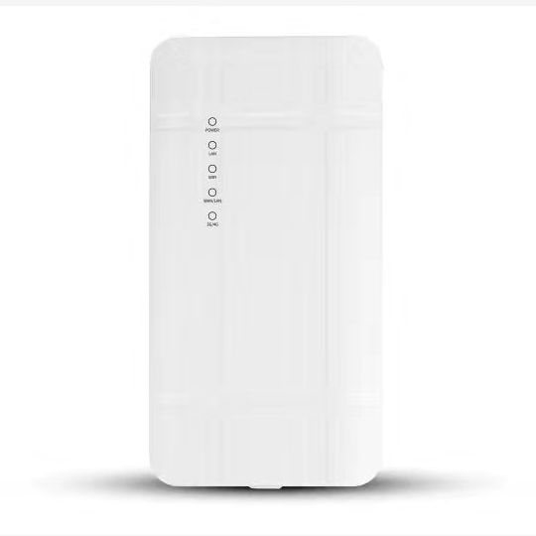
QC300K is a cost-effective wireless communication outdoor product developed based on 4G network requirements. It has full Netcom 4G network access, and is compatible with 4G/3G/2G network. The WiFi wireless speed is up to 300Mbps, which can meet the needs of outdoor equipment Internet access. It is widely used in the Internet of Things communication industry to provide users with wireless long-distance data monitoring, acquisition and transmission functions.

Product features


Outdoor industrial design, 300M wireless WiFi
It adopts outdoor IP65 windproof, rainproof, dustproof and sun protection grade shell design, which can easily adapt to various harsh outdoor environments. Built-in professional wireless processor, wireless speed up to 300Mbps, barrier-free transmission distance of about 100 meters, independent professional power amplifier and low noise amplifier, stable and smooth belt machine 30, not stuck, not dropped.
Powerful never crash system
Dual SOC hardware design, self-contained system detection mechanism, self-contained 4G network detection mechanism, self-contained intelligent recovery mechanism, long-term stable operation, never crash.
Simple to set up, flexible and versatile
The default 4G access mode is plug and play. Support 4G mode, routing mode, AP mode switching, built-in quick setup wizard, guide customers to complete the configuration easily. Routing mode, support for wired broadband access; AP mode, easily convert wired network into wireless WiFi network. Support 4G and wired broadband access modes, support mobile Unicom Telecom 4G/3G/2G network card, and have 4G Internet access advantage in places where wired bandwidth cannot reach, and easily access the Internet.
Multiple security policies to ensure network data security at all times
Support WPA, WPA2 wireless security access, support SSID hiding and wireless blacklist to effectively prevent network, and ensure user network data security at all times.
TR069 remote management
Support real-time view of device status parameters, batch remote device management, status notification, device agent management, and let the device have some control.
A variety of status statistics, always know the working status of the device
Built-in traffic statistics, support for traffic plan settings, easy to understand monthly traffic usage; multi-state work indicator, real-time work log view, always know the working status of the device.
Uninterrupted product feature updates and performance optimization
The R&D team with the spirit of craftsman has been constantly updating the functions to meet the needs of various network environments in a simple and efficient manner. The refined performance optimization ensures the best quality network products and enhances the user experience.

Product specifications
Product parameters
Hardware Configuration
Chip | MTK7628KN 300M High-performance enterprise chip
Frequency | 580MHz
Wireless Technology | 802.11b/g/n 300M MIMO technology
ROM | 2MB
Memory | 8MB
Interface | WAN/LAN 10/100Mbps Adaptive network interface*1  LAN 10/100Mbps Adaptive network interface*1  Standard SIM card
Antenna | 4G 2T2R 5dBi antenna*2  WiFi 2T2R 2.4G 5dBiantenna*2
Power consumption | ＜10W
Button | 1*Reset button，Press and hold for 3 seconds to restore factory settings
Indicator light | POWER、LAN、WIFI、WAN/LAN、3G-4G
Size/Weight | N/A，N/A
Working/storage temperature | -10℃～50℃/-40℃～70℃
Work/storage humidity | 5%～95%（Non-condensing）
WiFi Fature
RF Parameters | 802.11b/g/n:2.4~2.4835GHz
Modulation Mode | 11b：DSS:CCK@5.5/11Mbps,DQPSK@2Mbps,DBPSK@1Mbps  11g：OFDM:64QAM@48/54Mbps,16QAM@24Mbps,QPSK@12/18Mbps,BPSK@6/9Mbps  11n：MIMO-OFDM:BPSK,QPSK,16QAM,64QAM
Transmission rate | 11b: 1/2/5.5/11Mbps  11g: 6/9/12/18/24/36/48/54Mbps  11n: Up to 300Mbps
Receiving sensitivity | 11b: <-84dbm@11Mbps；  11g: <-69dbm@ 54Mbps；  11n: HT20<-67dbm HT40: <-64dbm
Transmit power | 11b: 18dBm@ 1~11Mbps  11g: 16dBm @ 6~54Mbps  11n: 15dBm@ MCS0~7
Communication standard | IEEE 802.3(Ethernet)  IEEE 802.3u(Fast Ethernet)  IEEE 802.11b/g/n(2.4G WLAN)
Wireless security | WPA/WPA2

4G feature
Network standard | LTE FDD/TDD、UMTS DC-HSDPA/HSUPA/WCDMA、GSM EDGE/GPRS
LTE-FDD(Hierarchical reception) | B1/B3/B5/B8
LTE-TDD(Hierarchical reception) | B34/B38/B39/B40/B41
WCDMA | B1/B5/B8
GSM | 900/1800MHz
Data | LTE:  LTE FDD：Up to 150Mbps（DL）/Up to 50Mbps（UL）  LTE TDD：Up to 130Mbps（DL）/Up to 30Mbps（UL）  UMTS：  DC-HSDPA：Up to 21Mbps（DL）  HSUPA：Up to 5.76Mbps（UL）  WCDMA：Up to 384Kbps（DL）/Up to 384Kbps（UL）  GSM：  EDGE：Up to 296Kbps（DL）/Up to 236Kbps（UL）  GPRS：Up to 107Kbps（DL）/Up to 85.6Kbps（UL）
Transmit power | Class 3 (23dBm±2dB) for LTE FDD bands  Class 3 (23dBm±2dB) for LTE TDD bands  Class 3 (24dBm+1/-3dB) for WCDMA bands  Class E2 (27dBm±3dB) for EGSM900 8-PSK  Class E2 (26dBm±3dB) for DCS1800 8-PSK  Class 4 (33dBm±2dB) for EGSM900  Class 1 (30dBm±2dB) for DCS1800
Sensitivity | FDD B1: -99dBm (10M) FDD B3: -99dBm (10M)  FDD B5: -100dBm (10M) FDD B8: -100dBm (10M)  TDD B34: -98dBm (10M) TDD B38: -100dBm (10M)  TDD B39: -98dBm (10M) TDD B40: -99dBm (10M)  TDD B41: -99dBm (10M) WCDMA B1: -110dBm  WCDMA B5: -110dBm WCDMA B8: -110dBm  EGSM900: -108dBm DCS1800: -108dBm

Software features
Operating mode | 4G、Router、AP
Number of supported users | 30 people
Management | Web
State | System status, interface status, routing table
Wireless configuration | WiFi basic parameter configuration / blacklist
Network settings | Operating mode  LAN/WAN Address setting
Traffic assistant | Traffic statistics / package settings / flow control
System | System Properties / Password Modification /  Backup Upgrade / System Log / Restart
Setup Wizard | Quick configuration wizard
Indicator flashing rule
POWER | Connect to the power supply, the POWER light is steady blue
2.4G | WiFi is turned on, 2.4G indicator is steady blue, flashing during data transmission
4G | The 4G network mode, and when the network is normal 4G, 4G blue lights on; the 4G 4G exception mode, flashing blue light
WAN/LAN | When there is data access, WAN/LAN indicator light blue
LAN | When there is data access, LAN indicator light blue

