# T-CPE1200K

4G Wireless Router

# Overview

T-CPE1200K is a new 4G LTE CPE with LTE CAT 4 technology. The router is mainly aimed at the office, home, security and IoT. It provides high- speed and reliable routing and data transmission capabilities，to meet their different application scenarios.

# Highlight

* MTK7621+7603+7612E CPU,
* Memory：256MB DDR2,
* 4G Module：LTE CAT4,
* Flash：32MB ,

# Highlight

* 1*10/100/1000Mbps RJ45 WAN 2*10/100/1000Mbps RJ45 LAN

1*2FF SIM Card

* Throughput：LTE CAT4

FDD-LTE 150Mbps/50Mbps

* Support Multiple Internet Connect：2G 3G，4G，PPPOE，APN
* Support ，SMS
* Radio rate up to 1200Mbps，support wireless security functions
* Suooport IPSec，PPTP，L2TP VPN
* Support Firewall：IP，MAC，Port Filtering and DMZ
* Support 3*10/100/1000Mbps RJ45,
* Support SIM/USIM/cell lock card and traffic
* Support multi-carrier (2G/3G/4G LTE),
* External reset button,
* Power supply：DC 12V 1.5A，
* Support external LED indicator,
* Button：Reset，WPS , WiFi,

statistics

* Support TR069 and upgrade online
* Support IPV4，IPV6 Protocol
* Support FOTA
* Support antenna：4*WIFI+2*LTE(Connector Connector for external antenna,5dBi gain.)

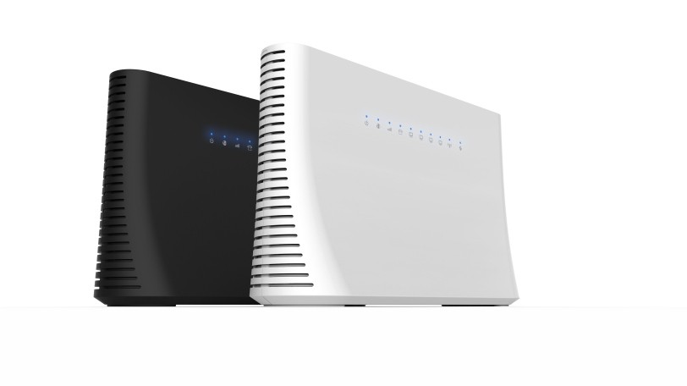

# Benefit

**Data Sheet**

## Wireless WAN Connectivity

The 4G router enables easy-to-install wireless connectivity in small business

or remote office locations. Ideal for small businesses ,home ,offices and mobile networks; the 4G router provides wired Ethernet, and 3G/4G wireless WAN connectivity to keep you and your business up and running.

## Secure and Reliable

a-LAN connections are protected with advanced WiFi encryption.

b-Main office access and business transactions are protected by VPN capability, and other security features to ensure your network stays secure.

c-Designed for small office/home /IoT/Security deployments.

## Product Architecture Diagram

**LTE CAT4**

**T-CPE1200K**

**4G Router**

**MTK7621+7603+7612E**

**Memory**

256MB

Flash

**32MB**

**Power**

**12V 1.5A**

**1GE* WAN**

**3*GE Ports**

**LAN/WAN**

**2GE* LAN**

# Hardware Speciﬁcation

Application Scenarios Concurrent Clients CPU

**Data Sheet**

Interface Button

Power Suppply

Flash/Memory SIM Card

LED

Dimensions Antennas Antenna Gain Frequency

Radio Rate

IPV4/IPV6

Wireless Security

Home，Office，IoT，Security 64

MTK7621+7603+7612E

1 *GE Mbps WAN 、 2*GE Mbps LAN

Reset，WPS， WiFi DC12V /1.5A 32MB/256MB

Micro SIM

PWR，WiFi，Internet，Ethernet，Signal(4 leds) , Voice 196*126.5*59.7(mm）

2.4G+5.8G :2T2R 5dBi

4G：2T2R 5dBi

802.11b/g/n：2.4~2.4835GHz

802.11a/n/ac ： 5.150～5.350GHz

2.4G: Up to 300Mbps

5.8G: Up to 900Mbps

Support

WPA-PSK/WPA2-PSK、WPA/WPA2

# Hardware Speciﬁcation

Modulation

Receiver Sensitivity

DSSS：CCK@5.5/11Mbps,DQPSK@2Mbps, DBPSK@1Mbps

OFDM：64QAM@48/54Mbps,16QAM@24Mbps,

QPSK@12/18Mbps,BPSK@6/9Mbps

MIMO-OFDM：BPSK,QPSK,16QAM,64QAM,256QAM

11b：-91dBm(1Mbps)，-88dBm(5Mbps)，

-85dBm(11Mbps)

11a/g：-89dBm（6Mbps），-80dBm（24Mbps），

-76dBm（36Mbps），-71dBm（54Mbps）

11n：-83dBm@MCS0，-65dBm@MCS7，

-83dBm@MCS8，-65dBm@MCS15

11ac HT20：-83dBm（MCS0）, -57dBm（MCS9）

11ac HT40：-79dBm（MCS0）, -57dBm（MCS9）

11ac HT80：-76dBm（MCS0）, -51dBm（MCS9）

4G Module

LTE CAT4

Frequency

GSM GNSS

Output Power

Firewall

4G LTE FDD：B1/B3/B5/B8

4G LTE TDD:B34/B38/B39/B40/B41

3G B1/B5/B8

900MHz/1800MHz

GPS, GLONASS, BeiDou/Compass, Galileo, QZSS Class 4 (33dBm±2dB) for GSM900

Class 1 (30dBm±2dB) for DCS1800

Class E2 (27dBm±3dB) for GSM900 8-PSK Class E2 (26dBm±3dB) for DCS1800 8-PSK

IP Filtering MAC Filtering Port Filtering DMZ

Lock

**Data Sheet**

Binding SIM Card/CELL lock

# Hardware Speciﬁcation

Class 3 (24dBm+2/-1dB) for CDMA BC0 Class 3 (24dBm+1/-3dB) for WCDMA bands

Output Power

LTE Features

UMTS Features

Class 2 (24dBm+1/-3dB) for TD-SCDMA bands Class 3 (23dBm±2dB) for LTE-FDD bands

Class 3 (23dBm±2dB) for LTE-TDD bands Support 3GPP R8 non-CA Cat 4 FDD and TDD Support 1.4MHz~20MHz RF Bandwidth

Downlink Support MIMO

LTE-FDD：Max downlink speed 150Mbps，uplink speed

50Mbps

LTE-TDD：Max downlink speed 130Mbps，uplink speed

35Mbps

Support 3GPP R8 DC-HSDPA，HSPA+，HSDPA，HSUPA and

WCDMA

Support QPSK，16-QAM 和 64-QAM Modulation

DC-HSDPA：Max downlink speed 42Mbps HSUPA：Max uplink speed 5.76Mbps

WCDMA：Max downlink speed 384Kbps，uplink speed

384Kbps

TD-SCDMA Features

Output Power

Support CCSA Release 3 TD-SCDMA

Max downlink speed 4.2Mbps，uplink speedq 2.2Mbps

Support 3GPP2 CDMA2000 1x Advanced and 1xEV-DO Rev.A EVDO：Max downlink speed 3.1Mbps，uplink speed 1.8Mbps 1x Advanced：Max downlink speed 307.2Kbps，uplink speed 307.2Kbps

SMS

Inbox、Outbox、Draftbox

Dispaly the number of read/unread SMS

VPN

展频技术

IPSec、L2TP、PPTP

maintenance

DSSS(直接序列展频)

**Data Sheet**

TR069，Upgrade online

# Product Specification

**Data Sheet**

|  |  |
| --- | --- |
| Mode | 4G Router |
| WiFi Setting | Wireless Setting、Channel bandwidth Setting、WPS |
| Status | CPU Status、Interface Status、4G Status Client List  Internet Status |
| Network | LAN WAN DHCP APN |
| Traffic assistant | Statistics and display the usage of traffic in 4G mode. |
| Sys | Username Managerment Reboot Upgrade/Restore/Bankup Sys time & date  Sys logs |
| Setting Guide | Type of connect Internet Network  WiFi |
| Operating Environment | Operating Temperature：Normal:0°C to +45°C; Operating Humidity：-20° C to +70° C Operating Humidity：5%~ 95%  Storage Humidity：5%~ 95% |